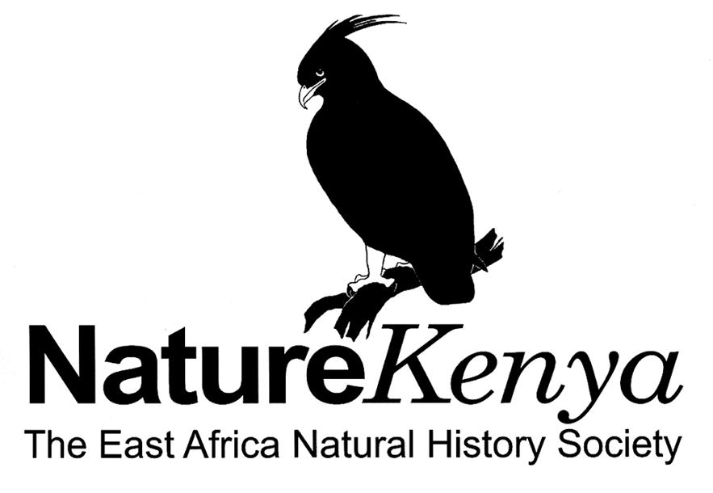
NatureKenya
The East Africa Natural History Society
P. O. Box 44486, 00100 Nairobi
Tel: +254 (020)-3749957/3746090
E-mail: office@naturekenya.org

Monitoring Important Bird Areas in Kenya
Help to monitor IBAs — key sites for biodiversity conservation!
Please answer the questions below;
Give details wherever possible
- Return a completed form once a year if you are resident at a site or a regular visitor
- Reports from any visit to an IBA are helpful. Please fill in relevant information any time.
- Consider making use of sketch maps as an additional means of recording key results. For example, use sketch maps to show the precise location & extent of threat, sighting of key species, extent of particular habitats, routes taken and area surveyed, etc.
- Return the completed form to the contact person at Nature Kenya or Ornithology Section, NMK.

PART 1. ESSENTIAL INFORMATION (please use a different form for each site)

Name of the IBA------------------------------------------------ Date----------------------------------Your name------------------------

------------------------------------------------------------- Postal address---------------------------------------------------------------

Telephone/fax-------------------------------------------------------email----------------------------------------------------------------

What area does this form cover? (tick one box)
 (a) The whole IBA or  (b) Just part of the IBA?

If (b), which part / how much of the whole area?
--------------------------------------------------------------------------------------------------------
--------------------------------------------------------------------------------------------------------

Do you live at or around the IBA?
 (a) Yes  (b) No

If (b) when did you visit the IBA and for how long?

---------------------------------------------------------------------------------------------------------

----------------------------------------------------------------------------------------------------------

What was the reason for your visit(s)?
.............................................................................................................................................................................................................................................................................................................



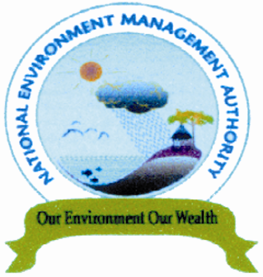



Part II. MONITORING THE IBA
Answer all the questions as much as you can and fill in all the tables (i.e. provide sufficient information)
Please attach or send more sheets or other documents or reports as necessary.

Note: Guidelines on how to fill this table is provided in the Appendix 1 below

THREATS TO THE IBA (‘PRESSURE’)
General comments on threats to the site and any changes since your last assessment (if relevant):
----------------------------------------------------------------------------------------------------------------------------------------------------------------------------------------------------------------------------------------------------------------------------------------------------------------------------------

THREAT TYPES | Score |  |  | Details
THREAT TYPES | Timing | Scope | Severity | Details
1. Agricultural expansion & intensification Give details of specific crops, e.g. oil palm, or animals, e.g. cattle
Annual crops - shifting agriculture
Small-holder farming
Agro-industry farming
Perennial non-timber crops- small holder plantations
Agro-industry plantations
Wood & pulp plantations – Small-holder plantations
Agro-industry plantations
Livestock farming & ranching – Nomadic grazing
Small-holder grazing, ranching or farming
Agro-industry grazing, ranching or farming
Marine & freshwater aquaculture,
Subsistence/ or artisanal aquaculture
Industrial aquaculture
2. Residential & commercial development Give details of type of development & issue
Housing & urban areas
Commercial & industrial areas
Tourism & recreation areas
3. Energy production & mining Give details of specific resource & issue
Oil & gas drilling
Mining & quarrying
Renewable energy
4. Transportation & service corridors Give details of specific type of transport & issue
Roads & Railroads
Flight paths
Shipping lanes
5. Over-exploitation, persecution & control of species Give details of issue
Direct mortality of ‘trigger’ species (those species for which the site is recognized as an IBA) – hunting & trapping
Persecution or control
Indirect mortality (by catch) of ‘trigger’ species-hunting
fishing
Habitat effects – gathering plants
logging
Fishing & harvesting aquatic resources
6. Human intrusions & disturbance Give details of specific activity & issue
Recreational activities
War, civil unrest & military exercises
Work & other activities
7. Natural system modifications Give details of the alteration & issue
Fire & fire suppression
Dams & water management and/or use
Other ecosystem modifications
8. Invasive & other problematic species & genes Give details of the invasive or problematic species & issue
Invasive alien species
Problematic native species
Introduced genetic material
9. Pollution Give details of pollutant, source if known (e.g. agricultural, domestic, industrial) & issue
Domestic & urban waste water
Industrial & military effluents
Agricultural & forestry effluents & practices
Garbage & solid waste
Air-borne pollutants
Noise pollution
10. Geological events Give details of specific event and issue
Volcanic eruptions
Earthquakes and tsunamis
Landslides
11. Climate change & severe weather Give details of specific event and issue
Habitat shifting & alteration
Drought
Floods
12. Other If the threat does not appear to fit in the scheme above, give details here of the threat, its source if known and how it’s affecting the IBA
1
2
3

BIRD POPULATIONS AND HABITATS (‘STATE’)
General comments on condition of the site and any changes since your last assessment (if relevant): ---------------------------------------------------------------------------------------------------------------------------------------------------------------------------------------------------------------------------------------------------------------------------------------------------------------------------------------------------------------------------------------------------------------------------------------------------------------------------------------------------
If you have estimates or counts of bird populations, or other information on the important bird species at the IBA, please summarise these in the table below:

Bird species or groups | Population estimate (Pairs or individuals) | Details / other comments

If you have information on the area of the natural habitats important for bird populations at the IBA, please summarise it below. Please note any major changes since the last assessment in the ‘details’ column.
Habitat area codes: Choose from Good (overall >90% of optimum), Moderate (70–90%), Poor (40–70%) or Very Poor (<40%)
If you do not know the actual habitat area, give your best assessment of the current habitat area at the site, in relation to its potential optimum if the site was undisturbed. The percentages are given as guidelines only: use your best estimate. Please justify your coding in the ‘details’ column.

Habitat | Current area (area code) if known (Include units e.g. ha, km² | Details /comments / changes
If you have information on the quality of the natural habitats important for bird populations at the IBA, please summarise it below. Please note any major changes since the last assessment in the ‘details’ column.
Habitat quality rating: Choose from Good (overall >90% of optimum), Moderate (70-90%), Poor (40-70%) or Very Poor (<40%).
Give your best assessment of the average habitat quality across the site, in terms of its suitability for the important bird species. The percentage ranges relate to the population density of the ‘trigger’ species in its key habitat. Thus 100% means that the species is at carrying capacity in its habitat. The percentages are given as guidelines only: use your best estimate. Please justify your selection in the ‘details’ column.

Habitat | Quality rating | Details /comments / changes

CONSERVATION ACTIONS TAKEN AT IBA (‘RESPONSE’)

General comments on actions taken at the site, including recent changes or developments

Please tick the box next to the text that applies for each of conservation designation, management planning and conservation action below. Please add any details and where appropriate give a brief explanation for your choice.

CONSERVATION DESIGNATION
Whole area of IBA (>90%) covered by appropriate conservation designation
Most of IBA (50–90%) covered (including the most critical parts for the important bird species)
Some of IBA covered (10–49%)
Little/none of IBA covered (<10%)
Details and explanation -----------------------------------------------------------------------------------------------------------------------------------------------------------------------------------------------------------------------------------------------------------------------------------------------------
MANAGEMENT PLANNING
A comprehensive and appropriate management plan exists that aims to maintain or improve the populations of qualifying species
A management plan exists but it is out of date or not comprehensive
No management plan exists but the management planning process has begun
No management planning has taken place
Details and explanation -----------------------------------------------------------------------------------------------------------------------------------------------------------------------------------------------------------------------------------------------------------------------------------------------------
CONSERVATION ACTION
The conservation measures needed for the site are being comprehensively and effectively implemented
Substantive conservation measures are being implemented but these are not comprehensive and are limited by resources and capacity
Some limited conservation initiatives are in place (e.g. action by Local Conservation Groups) Very little or no conservation action is taking place
Details and explanation ------------------------------------------------- --------------------------------------------------------------------------------------------------------------------------------------------------------------------------------------------------------------------------------------------------------

PART III INFORMATION ON PEOPLE, INSTITUTIONS AND THEIR ACTIVITIES

Please record any details of Local Conservation Groups (LCGs) (e.g. Site Support Groups (SSGs), Caretaker Groups) established at the site in the table below.

LCG name | Number of members | Male members | Female members | Other information

PART IV.ACTIVITIES UNDERTAKEN AT THE IBA

In the table below, please indicate the activities undertaken by any of the LCG, other CBO, the BirdLife Partner, Government agencies or other organisations or people at the IBA. This should include current activities, and activities carried out in the last four years.
Notes on action types
1. Land and water protection Actions to identify establish or expand parks and other legally protected areas
2. Land and water management Actions directed at conserving or restoring sites, habitats and the wider environment
3. Species management Actions directed at managing or restoring species, focused on the species of concern itself
4. Education & awareness Actions directed at people to improve understanding and skills, and influence behaviour
5. Law & policy Actions to develop, change, influence, and help implement formal legislation, regulations (including at the community level), and voluntary standards.
6. Livelihood, economic & other incentives Actions to use economic and other incentives and to influence behaviour
7. External capacity building Actions to build infrastructure resulting in better conservation, including through civil society development (e.g. enhancing community role in decision-making on natural resource use).

Action type | Action being undertaken by: |  |  |  |  | Details
Action type | LCG | Other CBO | Birdlife partner | Government | Other (specify) | Details
1. Land /water protection
Site or area protection
Resource & habitat protection
2. Land & water management
General site or area management
Invasive or problematic species control
Habitat &natural process restoration
3. Species management
General species management
Species recovery
Species (re)introduction
4. Education & awareness
Formal education
Training
Awareness, publicity & communication
5. Law & policy
Public legislation
Policies and regulation
Private sector standards & codes
Compliance, enforcement & policing
6. Livelihood, economic & other incentives
Linked enterprises & livelihood alternatives (e.g. ecotourism)
Substitution (alternative products to reduce pressure)
Market forces(e.g. certification)
Conservation payments
Non-monetary values (e.g. spiritual, cultural)
7. Capacity building
Institutional & civil society development
Alliance and partnership development
Conservation finance
8. Other (e.g. surveys, monitoring, research, EIAs)
1
2
3

PART V. ADDITIONAL INFORMATION

Please give any further information or details that you think may be helpful. For example _Number of conservation staff and volunteers _
Number of visitors _ Revenue generated _ Interesting bird records _ Lists or details of other fauna or flora _ Useful contacts (for research or conservation projects, tourism initiatives etc.) _ other notes. Please attach or send more sheets or other documents/reports as necessary.

----------------------------------------------------------------------------------------------------------------------------------------------------------------------------------------------------------------------------------------------------------------------------------------------------------------------------------------------------------------------
----------------------------------------------------------------------------------------------------------------------------------------------------------------------------------------------------------------------------------------------------------------------------------------------------------------------------------------------------------------------

Thank you for taking the time to fill in this form!

Appendix 1

Guidelines to score the threats to IBA in the above table, page 2
Please score each threat that is relevant to the important birds and habitats at the IBA. Threats should be based on your observations and information, and scored for Timing, Scope and Severity. In the ‘details’ column, please explain your scoring and make any other comments. Please note any changes in individual threats since the last assessment. If threats apply only to particular bird species, please say so.

Use the following guidelines to assign scores for Timing, Scope and Severity. The numbers are there to help you score, but are intended as guidance only. You don’t need exact measurements to assign a score. For scoring combined threats, Timing, Scope & Severity scores should either be equal to or more than the highest scores for individual threats; scores cannot be less than those allocated to individual threats.

Timing of selected threat ----------------------------------------------------------------------------------------------Timing score
Happening now ------------------------------------------------------------------------------------------------------------3
Likely in short term (within 4 years) ---------------------------------------- -------------------------------------------2
Likely in long term (beyond 4 years) -----------------------------------------------------------------------------------1
Past (and unlikely to return) and no longer limiting, ----------------------------------------------------------------- 0

Scope of selected threat-------------------------------------------------------------------------------------------------- Scope score
Whole area or bird population (>90%) -----------------------------------------------------------------------------------3
Most of area or bird population (50-90%) -------------------------------------------------------------------------------2
Some of area or bird population (10-50%) -------------------------------------------------------------------------------1
Small area or few individual birds (<10%) ------------------------------------------------------------------------------ 0

Severity of selected threat --------------------------------------------------------------------- --------------------------Severity score
Rapid deterioration ----------------------------------------------------------------------------------------------------------3
(>30% over 10 years or 3 generations whichever is the longer
Moderate deterioration ------------------------------------------------------------------------------------------------------2
(10–30% over 10 years or 3 generations)
Slow deterioration-------------------------------------------------------------------------------------------------------------1
(1–10% over 10 years or 3 generations)
No or imperceptible deterioration (<1% over 10 years) ---------------------------------------------------------------- 0

1. Agricultural expansion & intensification Threats from farming and ranching as a result of agricultural expansion and intensification, including silviculture, mariculture and aquaculture. Note that wood and pulp plantations include afforestation, and livestock farming and ranching includes forest grazing. Agricultural pest control and agricultural pollution-specific problems apply to ‘5. Overexploitation, persecution & control’ and ‘Pollution’ respectively, apply to 9
2. Residential & commercial development Threats from human settlements or other non-agricultural land uses with a substantial footprint; resulting in habitat destruction and degradation, also causing mortality through collision. Note that domestic or industrial pollution-specific problems apply to 9.
3. Energy production & mining Threats from production of non-biological resources; resulting in habitat destruction and degradation, also causing mortality through collision. Note that renewable energy includes wind farms.
4. Transportation & service corridors Threats from long narrow transport corridors and the vehicles that use them, including shipping lanes and flight paths; resulting in habitat destruction and degradation, erosion, disturbance and collision.
5. Over-exploitation, persecution & control Threats from consumptive use of wild biological resources including both deliberate and unintentional harvesting effects; also persecution or control of specific species. Note that hunting includes egg-collecting, gathering includes firewood collection, and logging includes clear cutting, selective logging and charcoal production.
6. Human intrusions & disturbance Threats from human activities that alter, destroy and disturb habitats and species associated with non-consumptive uses of biological resources.
7. Natural system modifications Threats from actions that convert or degrade habitat in service of managing natural or semi-natural systems, often to improve human welfare. Note that ‘other ecosystem modifications’ includes intensification of forest management, abandonment of managed lands, reduction of land management, and over grazing. ‘Dams & water management/use’ includes construction and impact of dykes/dams/barrages, filling in of wetlands, groundwater abstraction, drainage, dredging and canalisation.
8. Invasive & other problematic species & genes Threats from non-native and native plants, animals, pathogens and other microbes, or genetic materials that have or are predicted to have harmful effects on biodiversity (through mortality of species or alteration of habitats) following their introduction, spread and/or increase in abundance.
9. Pollution Threats from introduction of exotic and/or excess materials from point and non-point sources causing mortality of species and/or alteration of habitats. Note that domestic and urban waste water includes sewage and run-off; industrial and military effluents includes oils spills and seepage from mining; agricultural and forestry effluents and practices includes nutrient loads, soil erosion, sedimentation, high fertiliser input, excessive use of chemicals and salinisation; and air-borne pollutants includes acid rain.
10. Geological events Threats from catastrophic geological events that have the potential to cause severe damage to habitats and species.
11. Climate change & severe weather Threats from long-term climatic changes which may be linked to global warming and other severe climatic/weather events.

